


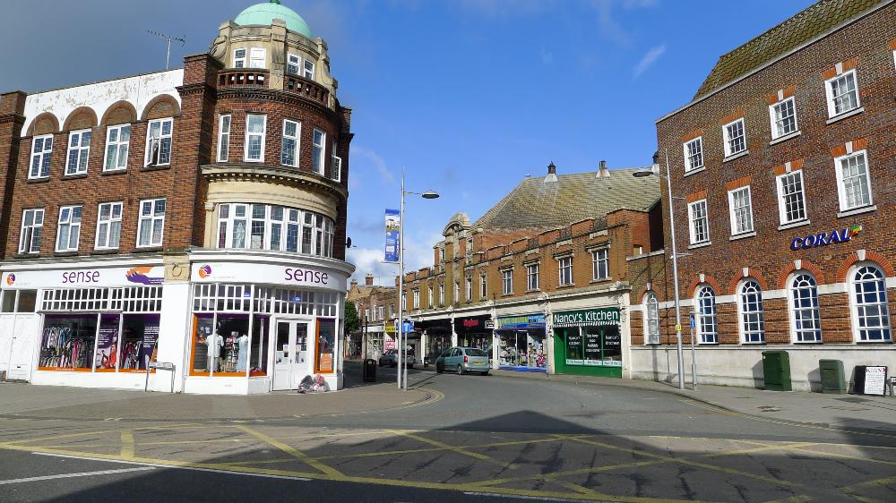
These guidance notes are provided to help you understand the aims of the Clacton on Sea, Holland on Sea & Jaywick Sands Capital Shopfront Grant Scheme (excluding the rest of Tendring) and how you can make a grant application.

ABOUT

Shop fronts are the most conspicuous part of a building’s façade. They make a big impact on the appearance of a town and village center, contribute to people’s first impression of a place and their condition affects a city’s image. High quality shop fronts make a town feel more welcoming to locals and visitors, improve its image, contribute towards a stronger sense of identity, and, importantly, encourage a greater number of shopping visits.
The shop front improvement grant scheme aims to improve shop fronts working in any sector, as long as they have a physical presence in Clacton on Sea, Holland on Sea or Jaywick Sands, (excluding the rest of Tendring), as a means of supporting the growth of local businesses, improving the local environment, and raising the image of the town & village centres amongst locals and visitors.
Amounts between £1,000 to £20,000 are available for capital work, for businesses with a physical premises in one of Tendring’s main town centres, High Streets or shopping areas within Tendring’s villages. Tendring District Council owned seafront premises i.e. kiosks that are ineligible for funding.
The grant scheme is funded through the Community Regeneration Partnership (CRP). The total amount available for funding through this scheme is £700,000.00, £150,000.00 of this is for Jaywick Sands businesses only.

WHO CAN APPLY?
All businesses with premises located within Clacton on Sea, Holland on Sea or Jaywick Sands, (excluding the rest of Tendring) who are looking to upgrade and improve their shop frontage, including those vacant, are eligible to apply to the fund. Lease-holders with a commercial shop-frontage must have at least 2 years remaining on their lease.
Examples of eligible commercial premises include:
- Shops (including hairdressers, beauty salons, funeral directors, laundrettes, dry cleaners and post offices)
- Restaurants, public houses, cafes and food takeaways
- Both tenants and building owners can apply.
Multiple businesses with the same owner are not eligible for support at more than one address. However, multiple premises owned by the same landlord are eligible, if more than one active tenant business applies for support.
If you are unsure whether your business will qualify for a grant, you should contact the scheme administrator at tendring4growth@tendringdc.gov.uk

AVAILABLE FUNDING
The scheme will provide funding up to a limit of £20,000 and there is no requirement to match fund, work must be capital works not revenue works.
Grants are discretionary and subject to availability of funds. The inclusion of a building within the eligible area does not give any automatic entitlement to a grant. The scheme will not support works which have already been undertaken or any works which are started prior to a formal offer of grant funding being made.
There are a limited number of grants available, and grants will be considered until the funding has run out.

WHAT WILL THE SCHEME FUND
Works must be an improvement to the property and not just a repair, works must also be in keeping within the surrounding area using neutral colours, all planning permission must be obtained by the person/business applying for the grant. If you receive a grant offer letter, no grant funding will be paid until proof of planning has been received by the Economic Growth Team. The planning portal can be found Introduction - The decision-making process - Planning Portal.
For more information on what information you may need to submit as part of your application, you can refer to the Local Validation List (tendringdc.gov.uk)
You can also seek pre-application advice from Tendring Planning team Pre-Application Advice (tendringdc.gov.uk) to help preparing your submission.
You can expect to wait a period of around 8 weeks between validation of your planning application.
When applying for the grant all colours of paint signs etc. that you are planning to use must be given, so it can be checked it is in keeping the with surrounding area.
If the shop is within a conservation area, please read the Conservation Areas Leaflet, which can be found at Conservation Areas (tendringdc.gov.uk) and make sure all the appropriate permissions have been granted. If you are applying for a grant in Frinton the Shop Front Design Guide must be kept to, which can be found untitled (tendringdc.gov.uk).

Help with the planning process
As planning permission is likely to be needed for most applications, we are contracting the services of a planning consultant who can help with the planning process on your behalf. The cost to use this service will be borne by the Community Regeneration Partnership and will not come out of your grant allocation, but planning fees must be paid for by the applicant upfront and can be claimed back if:

- the grant and planning permission is approved (or, alternatively, it is confirmed that planning permission is not required for the proposed works) and
- does not exceed the maximum grant amount (£20,000).

It is intended that the Planning Consultant will save applicants’ costs by being able to advise in advance whether planning permission will be required, removing the need for Pre-App costs, this will also ensure that the planning application is up to the standard required by planning, this will reduce the risk of the application being rejected or delayed. If an application is required on their advice, those costs are then eligible to be claimed back on the above criteria. If you wish to discuss further and/or use this service please email tendring4growth@tendringdc.gov.uk and we can put you touch with the consultant when they have been appointed.

Applied-for works must be external rather than internal property improvements, which includes but is not limited to:
- Fascia and Signage upgrades
- Doors and entrances (including adaptation for disabled access)
- Awnings (in windows visible from the street)
- External lighting

The list above is not exhaustive but indicates the type of projects the scheme could support. Any works must make a visible improvement to the external areas of the premises.

Please note that the following are not eligible for consideration:
- Non-fixed external items such as outdoor seating furniture, heaters, A-Boards or other moveable signage, or display furniture, mannequins etc.
- Core management and administration costs incurred during the day-to-day running of the business, i.e. rent, rates, staff costs or service charges
- Applications from national retailers, chains, banks or national charities

No works can be undertaken before the application has been approved by the Council, meaning a grant offer letter has been sent to and signed by the applicant, and all required planning permissions must be in place.

Please also note that monitoring & reporting requirements must be meet when a successful grant application is submitted, which are linked to Tendring District Council’s wider obligation to reporting back to Central Government as a condition of receiving this wider CRP allocation. This reporting relates to the following outputs and outcomes, not all of which relate to your project specifically but rather the wider Community & Place intervention

- Increased footfall
- Increased visitor numbers
- Improved perception of facilities/amenities
- Increased users of facilities/amenities
- Improved engagement numbers

Along with the monitoring & reporting requirements we are asking that all recipients of a grant that they keep their shop fronts clean, tidy and free from rubbish. This will help bring pride within Tendring and sits along the new Corporate Plan 2024 -2028.

Applications must include:
- A completed application form, submitted via email to tendring4growth@tendringdc.gov.uk
- Evidence of permission from a landlord to make changes to a property, if the property is leased (either as a letter or as a clause in the business’ lease)
- Proof of length of lease left, if the property is leased
- Two quotes for each aspect of the work being applied for. All details (for example, colours of paint selected, labour costs) must be included on the quotes provided so that the assessors can ensure they are two equivalent quotes. The applicant may indicate a preference for the more expensive of the two quotes and justify their choice for the assessor’s consideration. Local companies/tradespeople would be preferred where feasible, to support as many businesses through this scheme as possible.
- A photograph of the current outside of the business, to include the area of work applied for.

If your application is successful a grant offer letter will be issued to you to be signed and returned, but no funding will be paid until all relevant planning permissions are in place and proof of this has been received and acknowledged at the tendring4growth@tendringdc.gov.uk email address; this notification is the applicant’s responsibility. Payment can then take up to 30 days. All works to the shopfronts must be completed in a timely manner following the payment of any grant funds. A completion period of up to 12 weeks will be deemed reasonable.

Please note, this grant scheme is a competitive process and therefore, whilst we aim to support as many businesses as possible across the District, those who are ineligible or do not provide the above listed information upon request will be removed from consideration. There is a finite amount of money available, and the scheme will remain open to applications until such time as the full amount is allocated.

In the event that insufficient evidence of costs is provided, or where there is a high volume of interest, lower grant amounts may be offered where possible to support.

Due diligence checks will be completed on all applications, these will include NNDR payments are up to date and Companies House checks.

With any questions or to discuss further, please email tendring4growth@tendringdc.gov.uk.

